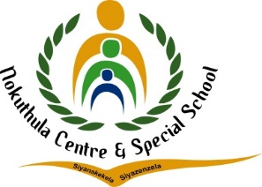


TEL: (010) 023 0609
E-MAIL: nokuthulasmh@mweb.co.za
NPO No: 001041
________________________________________________________
LESSON PLAN

Subject: English | Grade: 3 year 2 |  |  | Term: 1 |  |  | Week: 3-4
Topic: Me, My rights and responsibilities. |  | Content: Phonics | Time allocation: 3-4 week |  |  | Date Started: |  | Date Completed:
Prior content knowledge:  The teacher will ask learners to recite their rights and responsibilities and write them on the chalkboard. | Lesson objectives: The learners must be able to:  - Divide words into syllables  - Identify rhyming words  - Identify letter sound relationship of single letter |  |  |  | Vocabulary /Important word:  - Divide  - Identify |  |  |  | Teaching Strategies:  Demonstrate  Observation  Questions and Answers
Resources: Rights and responsibilities Chart  Chalkboard  Learners books | Teacher Activities: The teacher will write children’s rights and responsibilities on the chalkboard. The teacher will read the children’s rights and responsibilities to the learners, identify words that can be divided into three or more syllables. The teacher will also identify rhyming words. |  |  |  | Learner Activities: will divide words into syllables. Identify rhyming words from the rights and reasonability abstract. |  |  |  | Assessment Goal:  Assessment Strategy  Informal  Formal  Assessment tool: Rubric

Differentiation (Enrichment opportunities/addressing barriers) | Practical task
- Group 1: Break words into syllables and identify rhyming words.  - Group 2: rewrite the rhyming words.  - Group3: list the rhyming words. | Breaking words into syllables.
Teacher Reflection: | Name of Teacher: Sipho Madinga
HOD Input: | Name of HOD: Steven

